EXP-5

Lexicographically Smallest String Using Raptor
Aim
To design a flowchart using Raptor to obtain the lexicographically smallest string by swapping two characters at
most once.
Procedure
1. Open Raptor and create a new flowchart.
2. Design flowchart components:
• Input String
• Identify Characters for Swapping
• Perform Character Replacement
• Display Final String
3. Add flowchart logic:
• Accept a lowercase string from the user
• Find two characters whose swapping gives the smallest lexicographical order
• Replace all occurrences of first character with second character and vice versa
• Generate the final modified string
4. Execute the flowchart and validate output.
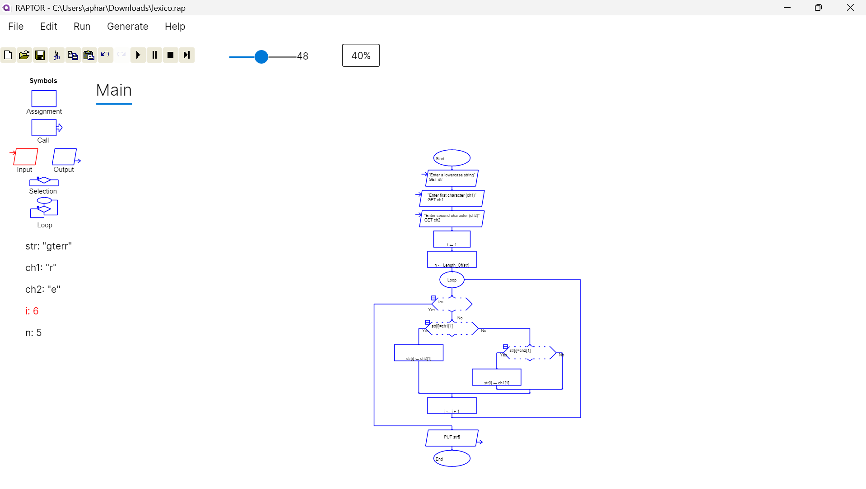
Result
Thus, the flowchart for obtaining the lexicographically smallest string using character swapping was created successfully using Raptor.

